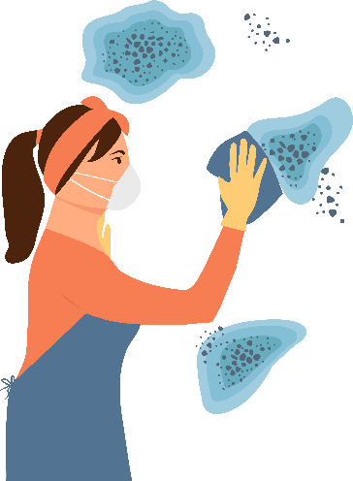
Mould after flooding -
preventing and cleaning up

Public Health Information Sheet

Mould is a sign of fungi growing in damp areas inside and outside the house. Mould produces tiny or invisible spores in large quantities and spores can cause serious health issues if you breathe them in. There is no practical way to eliminate all mould indoors. The best approach is to prevent its growth by controlling moisture.

What does mould look like?
Mould looks like “fuzz” or a stain, smudge or discoloration. The most common moulds are black, green or white, but can be other colours ranging from grey to orange to brown.

How does mould affect people?
Mould can trigger nasal congestion, sneezing, coughing and wheezing, and cause respiratory infections.
People with allergies, asthma or other lung diseases or with weakened immune systems may have worsening health if exposed to mould.

Mould growth after flooding
Flooding, pooled water and excess moisture
in a home can cause mould to grow. This may be a health risk for you and your family.
When returning home after a flood, look for visible mould and be aware of any musty smell.
Assume your home is contaminated with mould when:
- it has been flooded for more than two days
- there is water damage
- you can see mould
- you can smell strong, musty odours.
Seek advice from your insurance company BEFORE you start to clean-up, particularly prior to disposing of water or mould-damaged items.

What should I wear to protect myself in a flooded home?
If you are visiting your house to collect belongings, inspect for damage or to clean up, it is important to wear protective clothing:
- overalls,
- sturdy waterproof footwear with rubber soles,
- disposable gloves,
- protective eye goggles or glasses,
- suitable face mask, e.g. a P2 or N95 disposal respirator mask.
Drying out a house after a flood
To prevent mould growth, clean up and dry
out the house as quickly as possible (within
48 hours):
- Open all doors and windows to allow fresh air to circulate and help dry out the house quickly.
- Remove any pooled water from the home and fix leaks promptly to stop re-wetting of materials.
- Avoid using air conditioning or central heating systems exposed to floodwater until they have been professionally cleaned and electrically inspected.
- Once safe reliable power is restored, use fans and dehumidifiers to extract moisture and speed up the drying process.
- To prevent carbon monoxide poisoning, never use fuel-powered devices like generators, stoves, grills, or heaters indoors or in enclosed spaces.
- Salvageable items, including carpets, rugs, bedding, mattresses, furniture, stuffed toys, and clothing, may be kept if they can be thoroughly cleaned and dried to reduce the risk of mould or contamination. Assess each item carefully for mould or damage.
- Remove and discard items that cannot be effectively dried or restored, such as wallpaper and plasterboard.
- Remove wet wall linings like plasterboard, to allow internal wall spaces to dry.
- Disinfect and rinse all surfaces inside
the house, including floors and walls,
especially in areas like the kitchen, bathroom, and laundry.
- Store damaged or discarded items in a clean, dry place, such as a shed or garage, until insurance claims are processed.

Cleaning up mould
When dealing with large areas of mould,
seek advice from a professional mould removal specialist.
Small amounts of mould can be removed by, firstly using soap and water to clean the surface, then applying a commercial mould removal product or hypochlorite bleach.
- Mix 1 ½ cups of household bleach in 4 litres of water, apply to the affected area and leave for 10 minutes before rinsing and drying. Detergent may also be added to this solution, so it penetrates surfaces.
- Some organisations recommend sanitisers other than bleach, but there is no evidence they are any more effective than diluted bleach.

- These other sanitisers include organic acids (white vinegar) and alcohols (methylate spirits or isopropyl alcohol).
- Do not mix bleach with ammonia, acids or other cleaners – this can release hazardous chlorine or chloramine fumes. Read product labels before use.
- Avoid spreading the mould through areas that are not contaminated. Rinse cleaning cloths often and dispose of in a sealed plastic bag after use.
- Avoid using water blasters as this can cause mould spores to become airborne.
- After treating the area and allowing time to dry, vacuum the room using a high efficiency particulate air (HEPA) filtered vacuum cleaner.
- Regularly take breaks and make sure you wash your hands and face with soap before eating, drinking, smoking, or vaping (hand sanitiser may not work on soiled hands).
- If you cut yourself or break the skin, stop work and apply first aid including cleaning the wound. Seek medical attention if you think the cut is deep or have signs of infection.
When you are finished
- Seal your mask and disposable gloves in
a plastic rubbish bag for disposal.
- Immediately wash your hands, arms and face with warm soapy water or shower using soap to remove any remaining mould.
- Wash all protected clothing separately from regular laundry. Consider wearing
a mask and gloves when handling these clothes, especially if they are muddy or dusty.

